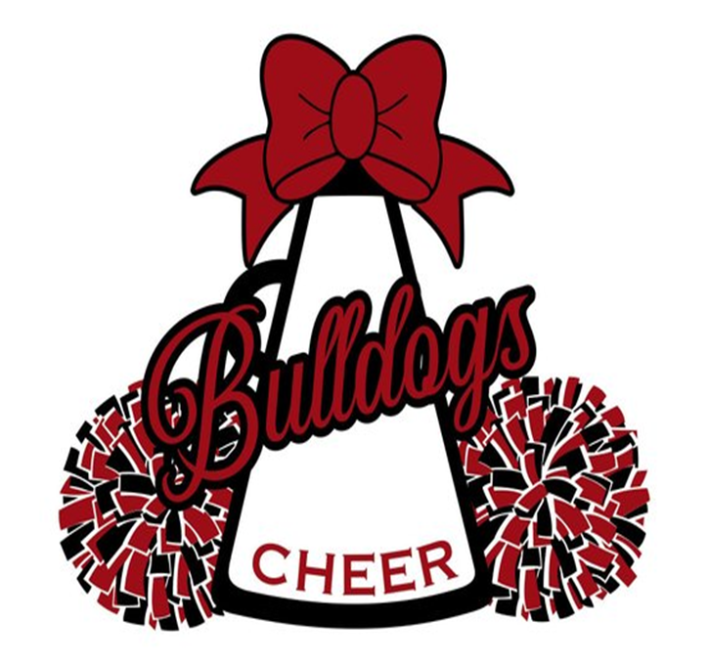

Heights Cheer/Mascot Tryouts

**IMPORTANT DATES**

**Informal Parent/Candidate Information Meeting:**

February 25, 2022

5:00-6:00

TEAMS

**Cheer Skills Clinic(voluntary):**

March 7-10, 2022

4:30-6:30

Heights HS GYM

**Tryout Clinic(mandatory):**

March 21-23, 2022

4:30 pm-6:30 pm

Heights HS GYM



**Cheer/Mascot Tryouts:**

March 24, 2022

4:30- until the conclusion of tryouts

Heights HS GYM

**Tryout Fee: $20 due March 7, 2022**